**Create external view**

The scripted calculation view created through Modeler perspective is not visible in SE11.

Hence, an external view is created. This external view is visible through SE11.

1) ABAP Perspective

2) Right click on package Z001- new-other-**Dictionary view**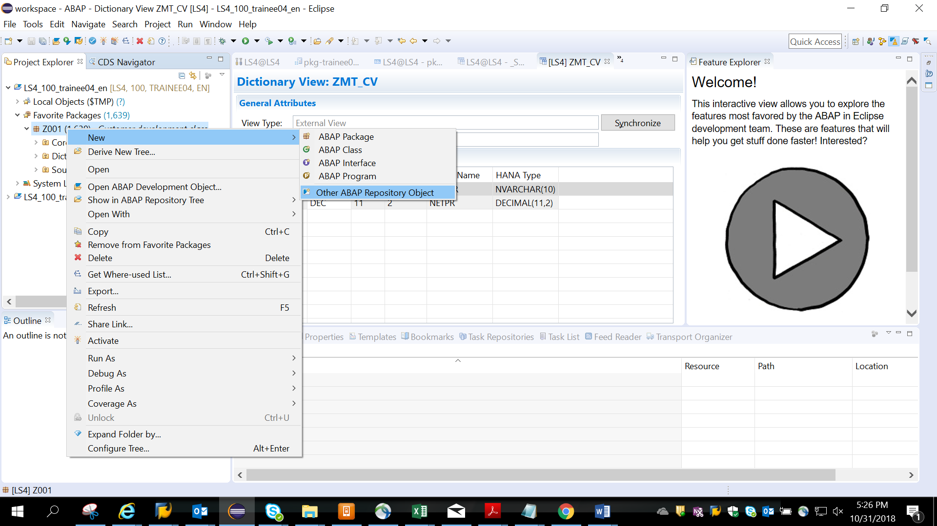

3)Search for Dictionary view

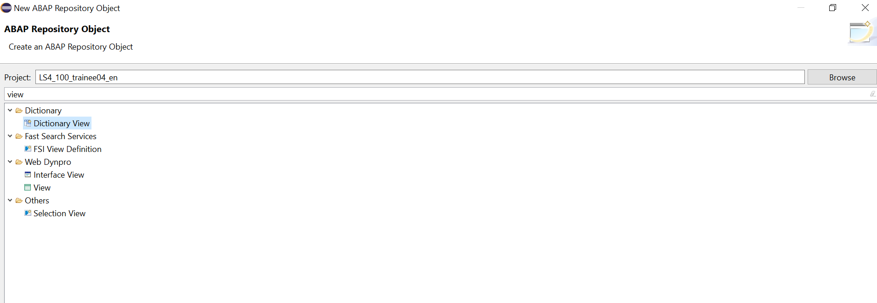

3)choose externalView radio button

External View Name: **ZMT_CV**

Hana View: **MT_CV**

Note: Dictionary View name must begin with Z.

Give the HANA calculation view MT_CV created in earlier demos t

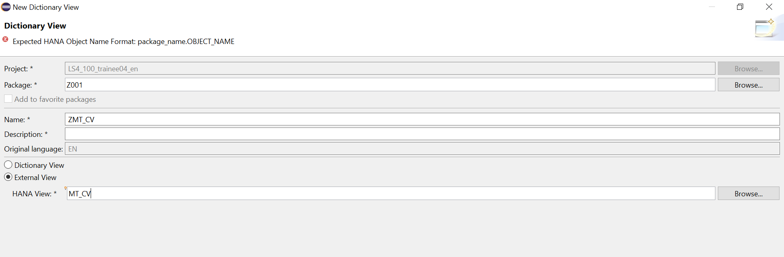

4)Click on browse, the Hana View with package is populated

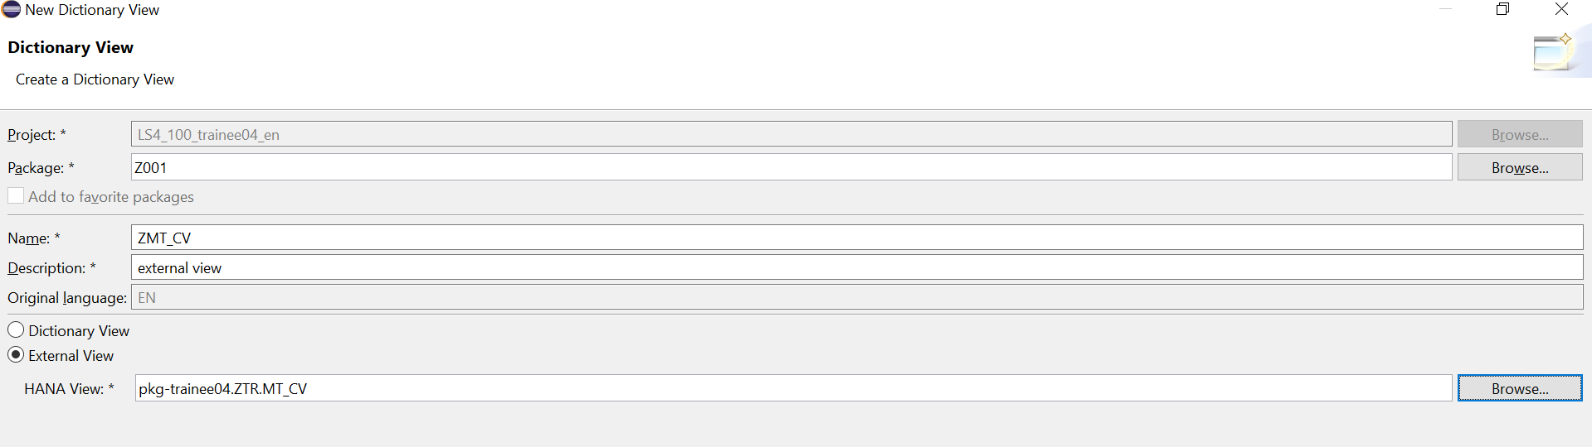

5)choose any package and Finish

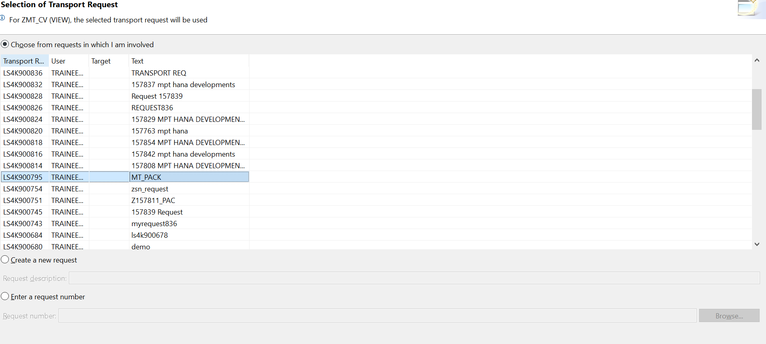

6)Synchronize and

7) activate- Run as ABAP Application

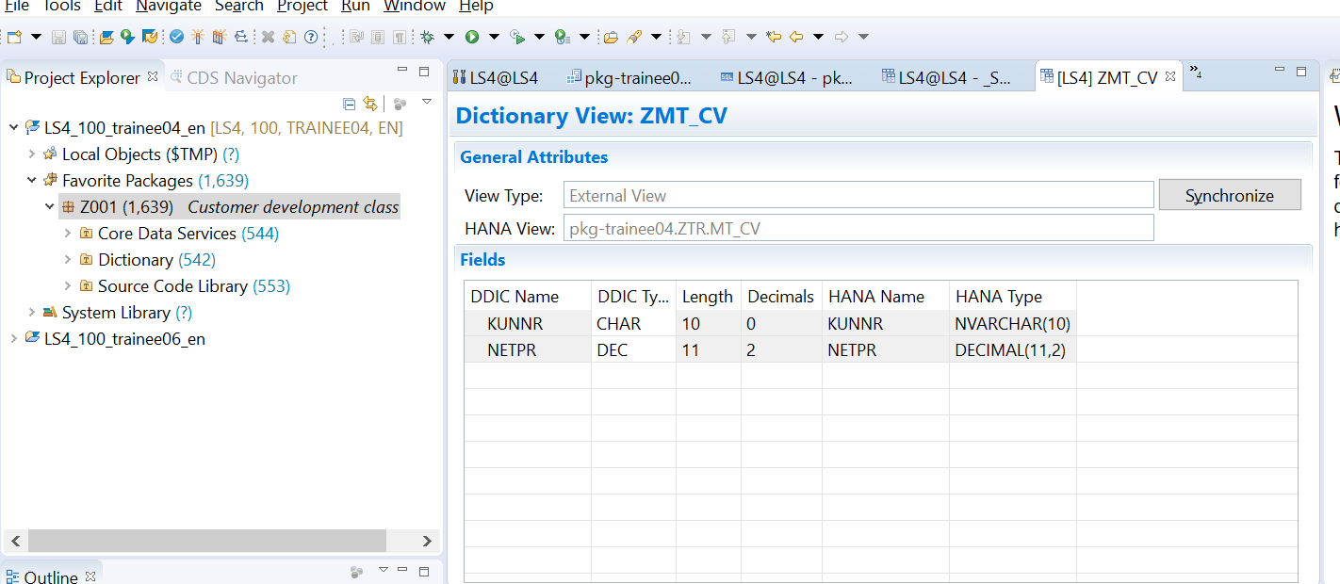

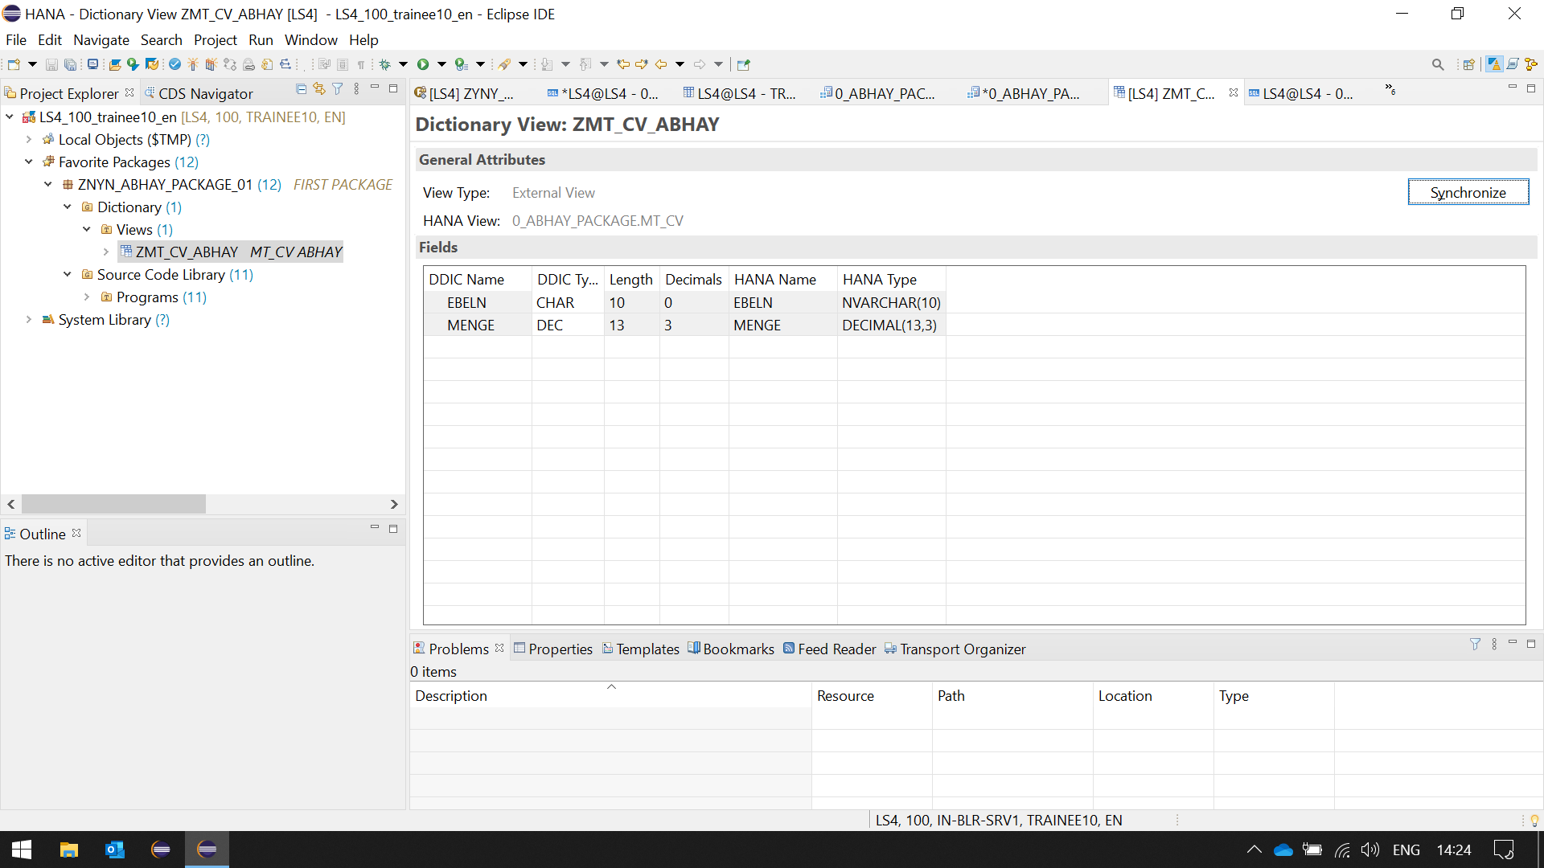

7)Check the view in SE11

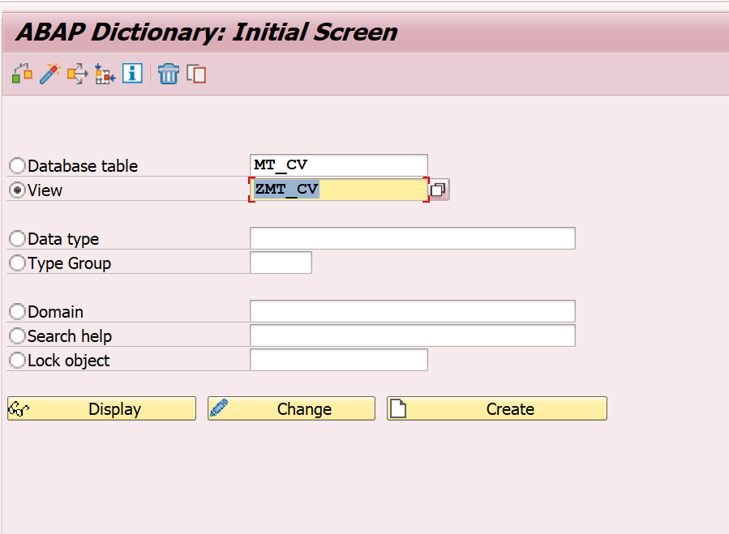

8) 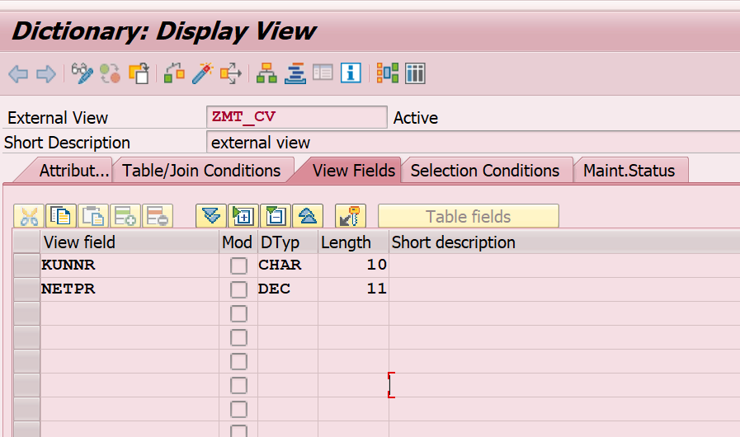

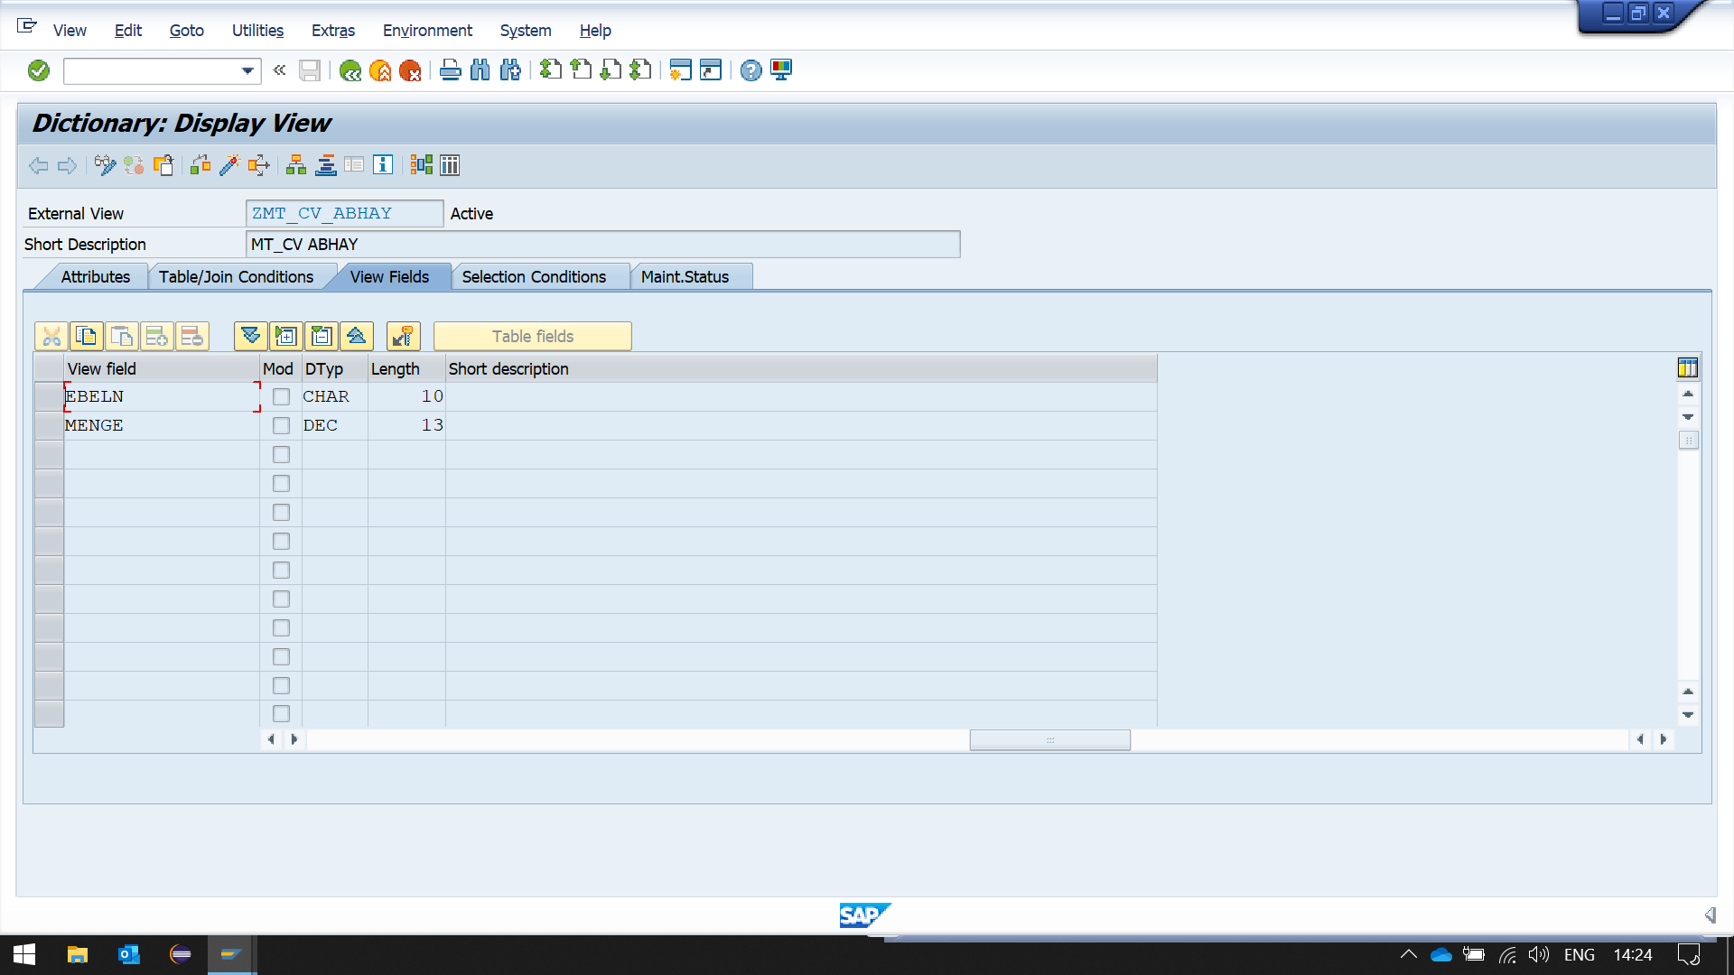

9) Create se38 program with below code

REPORT Z.  
DATA IT_SALES TYPE TABLE OF ZMT_CV.  
SELECT * FROM ZMT_CV INTO TABLE IT_SALES.  
CL_DEMO_OUTPUT=>DISPLAY(  IT_SALES ).

*\*&---------------------------------------------------------------------\**  
*\*& Report ZYNY_ABHAY_EXTERNAL_VIEW*  
*\*&---------------------------------------------------------------------\**  
*\*&*  
*\*&---------------------------------------------------------------------\**  
REPORT ZYNY_ABHAY_EXTERNAL_VIEW.  
  
DATA IT_SALES TYPE TABLE OF ZMT_CV_ABHAY.  
SELECT * FROM ZMT_CV_ABHAY INTO TABLE IT_SALES.  
CL_DEMO_OUTPUT=>DISPLAY(  IT_SALES ).

10)Save and activate.

